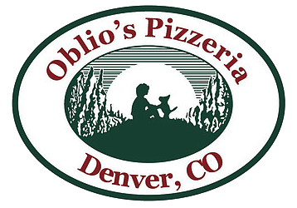

Dine Out Night for Teller at Oblio’s Pizzeria!
Tuesday, May 6th 11am-10pm ALL DAY!
6115 E 22nd Ave, Denver, CO 80207
Mention Teller School Fundraiser when placing your order and 20% will be donated back to our school! For online orders put Teller in the comments section to get the % back.

