RFMA FEBRUARY MENU
2025
Nam id velit non risusonsequat iaculis.

Monday | Tuesday | Wednesday | Thursday | Friday
3 | 4 | 5 | 6 | 7
WG Cocoa Puff Cereal Bar 1ea  100% Juice  Fresh Apple  Breakfast Burrito  Scrambled Eggs  Cheddar Cheese, Salsa  Hash Browns  Blue Raspberry Sidekick | Maple Waffle  Dried Apples  Fresh Orange  Chicken Nuggets  Buttermilk Biscuit  BBQ Sauce  Steamed Carrots  Green Apple | Vanilla Yogurt  Honey Granola  100% Juice  Sliced Peaches  Beef Meat Sauce  Rotini Pasta  Steamed Broccoli  Cinnamon Peaches | Banana Chocolate Chip Oatmeal Round  Dried Fruit  Fresh Banana  Chicken Fajitas  Onions, Peppers  Tortillas, Salsa  Black Beans  Orange Quarters | Pumpkin Bread  String Cheese  100% Juice  Applesauce Cup  Cheese Stuffed Breadsticks  Marinara Dipping Sauce  Mixed Veggies  Cinnamon Apples
10 | 11 | 12 | 13 | 14
Strawberry Cinnaboli  100% Juice  Fresh Apple  Turkey Hot Dog  Wheat Bun, Ketchup  Baked Beans  Fruit Cup | Cocoa Puffs Bowl  Dried Apples  Fresh Orange  Orange Chicken  Brown Rice  Steamed Carrots  Cinnamon Apples | Lemon Poppyseed Bread  String Cheese  100% Juice  Fruit Cup  Meatballs in Marinara  Garlic Knot  Steamed Broccoli  Fresh Banana | WG Cocoa Puff Cereal Bar 1ea  String Cheese 1ea  Dried Fruit  Fresh Banana  Crispy Chicken Sandwich  Wheat Bun  Buffalo Sauce  Steamed Corn  Orange Quarters | No School
17 | 18 | 19 | 20 | 21
President’s Day | WG Cocoa Puff Cereal Bar 1ea  String Cheese 1ea  100% Juice  Fresh Green Apple  Chicken Burrito Bowl  Rice, Pinto Beans  Cheddar Cheese, Salsa  Strawberry Mango Sidekick | Mini Bagels w/Strawberry Cream Cheese  100% Juice  Applesauce Cup  Cheese Calzone  Marinara Dipping Sauce  Steamed Peas  Cinnamon Peaches | Cinnamon Roll  Dried Fruit  Fresh Banana  Chicken Nuggets & Waffles  Syrup  Steamed Carrots  Orange Quarters | Apple Cinnamon Bread  100% Juice  Fruit Cup  Grilled Cheese  Steamed Corn  Cinnamon Apples
24 | 25 | 26 | 27 | 28
WG Cocoa Puff Cereal Bar 1ea  100% Juice  Fresh Apple  Meatball Sub  Marinara Sauce  Hoagie Roll  Steamed Carrots  Fruit Cup | Maple Waffle  Dried Apples  Fresh Orange  Breakfast Sandwich  Buttermilk Biscuit  Egg Patty  Cheddar Cheese  Hash Browns  Fresh Green Apple | Vanilla Yogurt  Honey Granola  100% Juice  Sliced Peaches  Cheese Lasagna Roll Up  Romaine Salad  Ranch Dressing  Cinnamon Apples | Apple Cinnamon Oatmeal Round  Dried Fruit  Fresh Banana  Beef Soft Tacos  Cheddar Cheese  Tortillas, Salsa  Refried Beans  Orange Quarters | Pumpkin Bread  String Cheese  100% Juice  Applesauce Cup  Turkey & Cheese Croissant  Deli Turkey  Sliced Cheddar  Celery Sticks  Ranch Dip  Applesauce

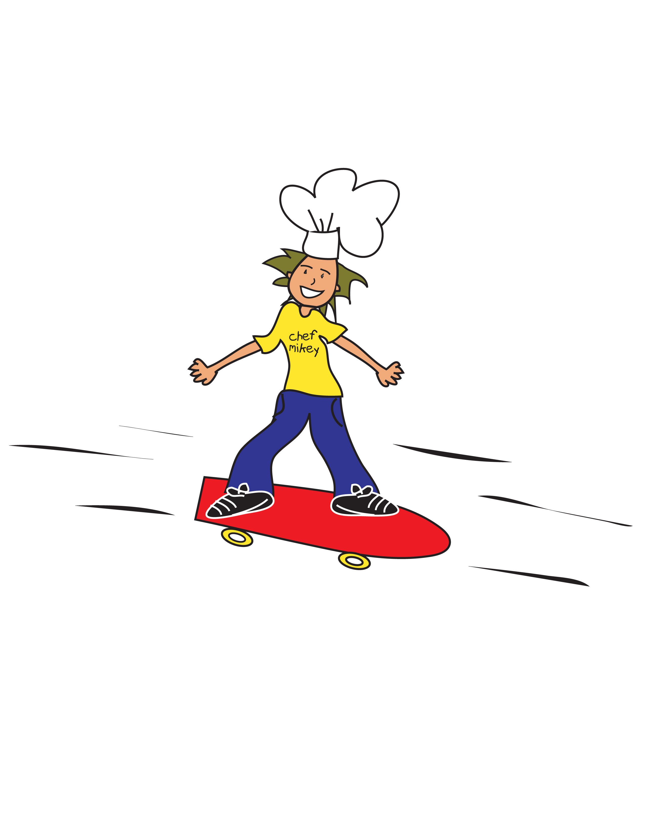

*This institution is an equal opportunity provider.
**All meals are served with a choice of 1% or skim white milk. Chocolate milk is offered on Fridays.
***This menu is subject to change based on item availability
****Shelf stable meal kits available upon request.
Our menu items may contain milk, eggs, wheat, soy, sesame, fish or shellfish.

