Support Teller Elementary Spirit Night

Tokyo Joes Cherry Creek location will donate 25% of the sales our supporters generate before tax on Wednesday, November 13th from 4 PM – 8:30 PM. This is a fantastic opportunity to show your support for our School and enjoy great Signature Bowls, Sushi and Small Bites!

Details:
- Wednesday, November 13th | 4- 8:30 PM
- Place your Order by:
  - Visiting the Restaurant or ordering online
Cherry Creek Mall 3000 E 1st Ave #100 Denver, Co 80206
  - Calling 303.357.8212

  - Order online at: https://order.tokyojoes.com/search

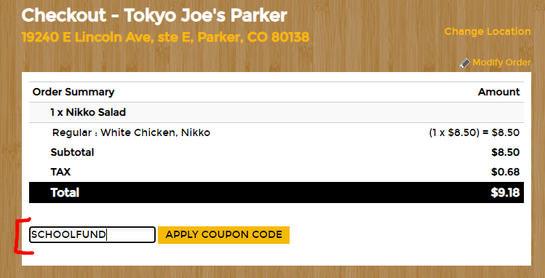

Be sure to mention Teller Elementary or bring this flyer with you. If you are ordering online be sure and use the coupon code SCHOOLFUND in all caps to ensure our school gets credit for the order
