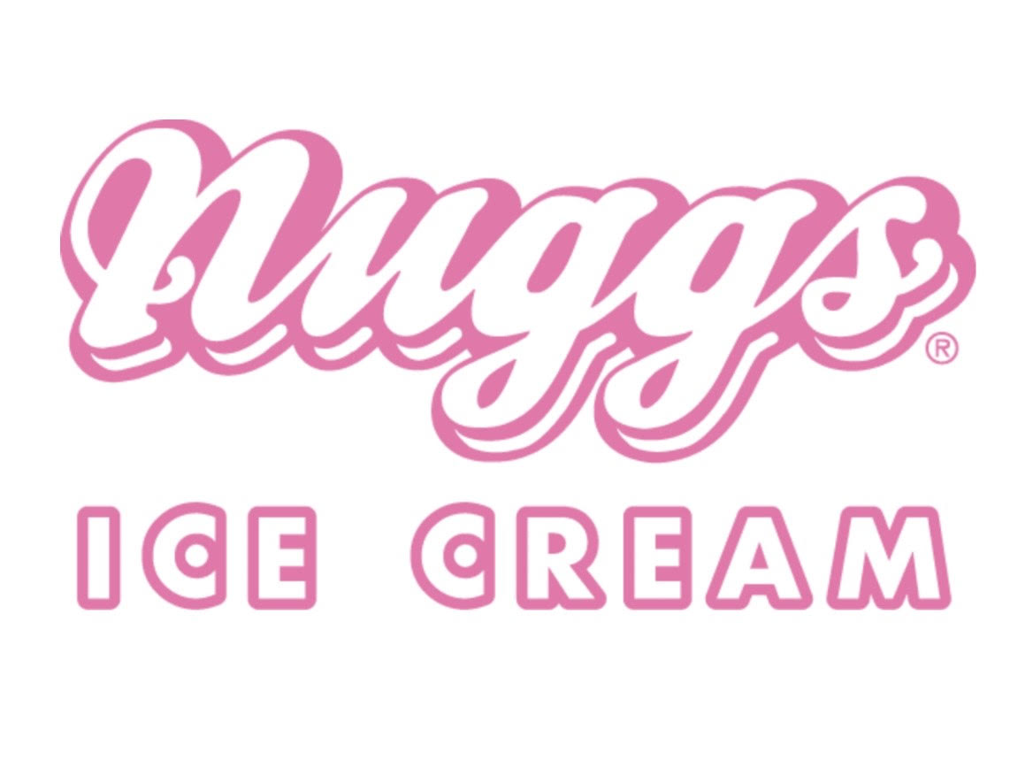

Come out to Nuggs and support Teller on Wednesday May 15th from 5pm-8pm!

Nuggs will donate 20% back to our school from ALL sales made in that timeframe that night!

Nuggs Ice Cream Shop
5135 East Colfax Ave

