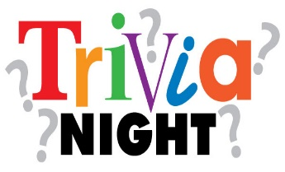
Alburnett Lions Club
Mulligans will be sold before trivia. 10 for $20.
Bring a snack to share and your own beverages. Lemonade & water provided. No alcohol allowed
7th Annual

Who: You, your friends or family!
Maximum of 8 people per table

What: Alburnett Lions 7th Annual Trivia Night

Where: Alburnett Community School – Elementary gym

How much: $15 per adult or $100 per table;
$10 per student or $50 per table for STUDENT ONLY groups

When: Saturday, March 11, 2023: Doors open at 5:15 p.m. Judging for Best-Themed Team & Decorated Tables will begin at 6:10 p.m. Free mulligans for 1st, 2nd, & 3rd place teams! Trivia begins at 6:30 p.m.

Why: The proceeds will go to the Alburnett Lions Foundation to help fund Operation PiratePack, Pirate Meals, & other Community projects. Operation PiratePack provides a nutritious bag of kid-friendly, non-perishable food for children & teens (on free & reduced lunch) on weekends and school breaks. Pirate Meals provides extra meals for needy families and individuals in our community during holidays and school breaks. These programs are both available at no cost to the parents/guardians or community participants and are not funded through the School.

Raffle, Silent Auction, & Door Prizes throughout the evening!

Prizes: First place team will win $200. Second place will receive $100.
- The table with the best-themed team & decorated table will win 5 free mulligans; the 2nd place team will win 3 free mulligans, and the 3rd place team will win 1 free mulligan! Judging will begin at 6:10 p.m.
Team registrations only, please. No walk-in registrations.

Trivia game information will be available on the tables.

Questions: Contact Jim Carver at 842-2629 or jrcarver40@outlook.com or Dani Trimble at dtrimble@alburnettcsd.org.

Please return bottom portion and check to Alburnett Lions, c/o Jim Carver, P.O. Box 222, Alburnett by March 8th or register on-line at http://tinyurl.com/LionsTrivia2023.
---------------------------------------------------------------------------------------------------------------------------------------------
Team Name:____________________________________________________________________
Team Captain:___________________________________________________________________
(Team Captain will be contacted if any questions are needed.)
Phone #__________________________________ Email ________________________________

Team Members Names: Up to 7 (Please, do not include Team Captain’s name here.)
________________________________________ ______________________________________
________________________________________ ______________________________________
________________________________________ ______________________________________
________________________________________

